**F R E O N L O C K™. “Thinking outside the cap.” Patent Pending**

**A/C port valve locking device to prevent Freon huffing, theft, or unauthorized access.**

(Inventor of the QB1 and QB2 condensate blow out valve, Hurricane Pipe stand, and Freezestat)

**FREE SAMPLE OF 6** with free wrench, to any A/C Company or HVAC Supply House.

☺**20 YEAR WARRANTY.** No corrosion. No rust. **Meets ALL code requirements.**

**100% STAINLESS STEEL.** Designed by actual tech. Saves time. **SALT WATER PROOF**.

To order email: [mikesears061@gmail.com](mailto:mikesears061@gmail.com). Cell: 214-597-2067.

From SEARCO: [www.HVACcraft.com](http://www.HVACcraft.com) Sold through wholesale houses only.

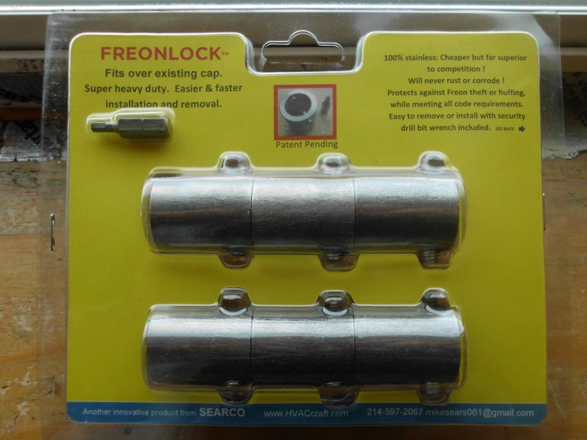CLAM SHELL PACKAGING WITH PET PLASTIC: 6 FREONLOCKS Shown over cap with security set screw in place.

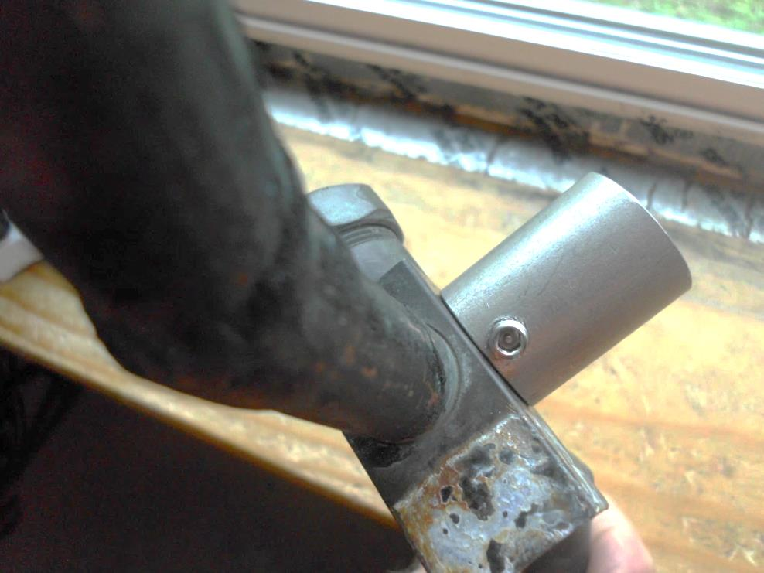 Use drill with wrench to tighten or loosen very quickly:

Extra set screws and wrenches are also sold separately.

FREE wrench included with each purchase of FreonLocks™

**LESS EXPENSIVE THAN THE COMPETITION, GUARANTEED!**